20. Implementing Distributed Database System and Handling Data Partitioning.

Create Database
create database school15;
use school15;
create table student2(
student_id int primary key,
name varchar(50),
city varchar(50),
department varchar(50));

Create Tables
create table course2(
course_id int primary key,
course_name varchar(50),
credits int);

Insert Sample Data
insert into student2 values
(1,'Gauri','Mumbai','Computer Science'),
(2,'Bhavana','Delhi','Mathematics'),
(3,'Tanvi','Mumbai','Physics'),
(4,'Shreya','Delhi','Computer Science');

Horizontal Partitioning
create table student_Mumbai as
select*from student2
where city='Mumbai';
create table student_Delhi as
select*from student2
where city='Delhi';

Vertical Partitioning
create table student_personal as
select student_id,name,city
from student2;
create table student_academic as
select student_id,department
from student2;

Check Storage Engines
show engines;
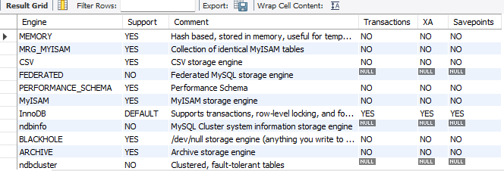

Combine Horizontally Partitioned Tables
select*from student_Mumbai
union
select*from student_Delhi;
